Documentation of Current Model and Features used , and results obtained for Stochastic Model   
  
1) Create model using features:

* Stochastic indicator
* Moving average

2) Moving Average Indicator.

* Create signal for uptrend (price above ma50)

3) Stochastic Indicator.

* Create the "H14" column in the DataFrame
* Create the "%K" column in the DataFrame
* Create the "%D" column in the DataFrame
* A buy is initiated when the %K line crosses up through the %D line and the value of the oscillator is below 35. This is called OVERSOLD.
* A buy is also initiated when intercept with uptrend signal
* A sell is initiated when the %K line crosses down through the %D line and the value of the oscillator is above 85 .This is called OVERBOUGHT.

4) The most significant level for semiconductor sector

* Overbought = 80
* Oversold = 35

5) Strategy for combination of Stochastic and Moving average

* Record all buy entry,between the period gap of the nearest sold entry.

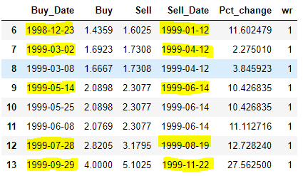

* Record transaction buy price for close, open, high, low, date and volume when oversold.
* Record transaction sell price for close and date when overbought.
* Using record buy and sell to create column percentage change and winning rate.

6) Loop this strategy for semiconductor sector and combine all into csv data.

7) Separate input features(close, open, high, low, volume,name of stock) and target(winning rate)

### 8) Use Resampling Techniques(Oversample minority class) to solve problem of imbalance data.

9) Train test split follow sequence(test_size=0.40, shuffle=False).

10) Trying logistic regression again dataset

11) Classification report

* training score: 0.50
* test score: 0.24

### 